

Hospitality Complex

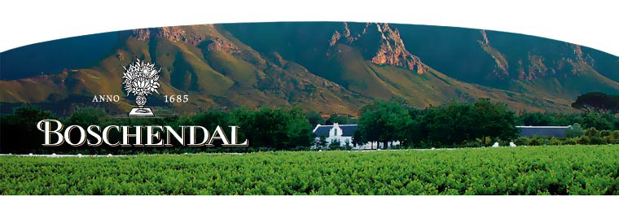

THE CELLAR DOOR – Wine Tasting Centre

Wine Tasting
The Boschendal Cellar Door (tasting centre) offers visitors the chance to taste and purchase the full range of Boschendal Wines. Conducted wine-tastings can be organised for groups.

Opening hours: | 10h00 – 18h30 – Monday to Sunday (October to March )  9h00 -16h30 – Monday to Sunday (April to September )
Individual tasting (five wines): | R 15 per person
Conducted group wine tastings (five wines): | R 25 per person
Cellar Tours  Vineyard Tours | R 20 per person - Booking Essential  R 30 per person – Booking Essential

Vineyard Tour (Nov. - Apr.)
Visitors are asked to book for our vineyard tour, which lasts approximately 1 hour and follows a route through the vineyards to a spectacular viewpoint on the slopes of the Simonsberg Mountain. During the tour visitors are given the history of Boschendal and its viticultural heritage.

Tour times: | 10:30 & 11:30 & 15:00 – Monday to Sunday
Booking essential: | Tel.: +27 (0) 21 870 4210/11
 | Email: info@boschendal.com

Cellar Tour (May. - Oct.)
Visitors are asked to book for our cellar tour, which lasts approximately 45 minutes. During the tour visitors are given the history of Boschendal and its viticultural heritage.

Tour times: | 10:30 & 11:30 & 15:00– Monday to Sunday
Booking essential: | Tel.: +27 (0) 21 870 4210/11
 | Email: Email: info@boschendal.com

Exhibition Vineyard
Visitors are given the opportunity of walking through a vineyard where they can view the South African grape varietals and our viticultural practices at close range.

WAENHUISWINKEL – GIFT SHOP

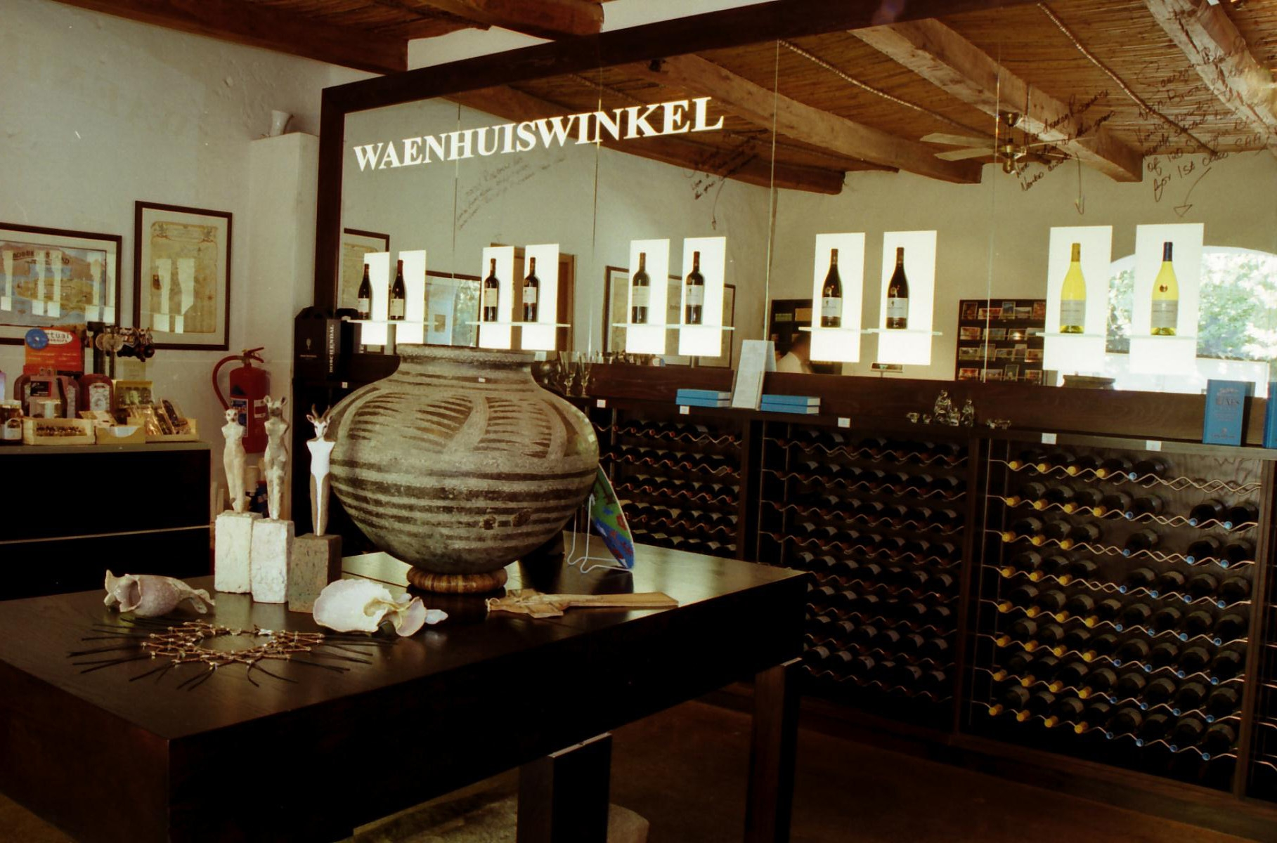
The Boschendal gift store is situated in the old coach-house and offers a wide range of handcrafted gifts and souvenirs.

Opening hours: | 09:00 - 17:00 daily

BOSCHENDAL RESTAURANT
Situated in the original cellar of the Manor House, the restaurant serves delicious extensive buffet luncheons daily. The generous Cape cuisine is perfectly complemented by Boschendal's fine wines.

Opening hours: | Sherry served from 12:15  Lunch served from 12:30 – guests to be seated by 13h30
Cost: | R240.00 per head excluding beverages and service (children aged between 2 and 10 years charged half price)
Booking essential: | Tel.: +27 (0) 21 870 4272/3/4/5  Fax: +27 (0) 21 874 2137  Email: Email: info@boschendal.com  Maximum seating capacity: 120  Dress Code: Smart Casual  No BYO – No Bring Your Own Wine.

LE PIQUE-NIQUE

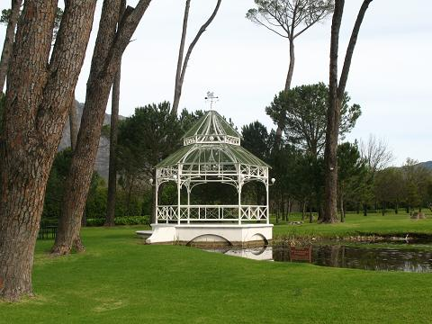
During the summer months Boschendal's Le Pique-Nique provides the ideal setting for simple French-Style country meals. Picnic hampers filled with simple country fare are served from a gazebo, relax and enjoy the fare at tables and chairs set in the shade of fragrant pine trees.

Opening hours: | 13 October – 15 May (weather permitting - cancelled if raining)  Baskets to be collected between 12:15 & 13:30. They may be collected later – by arrangement.
Cost: | R150.00 per adult excluding beverages and service  R59.00 per child (under 10) excluding beverages and service
Booking essential: | Tel.: +27 (0) 21 870 4272/3/4/5  Fax: +27 (0) 21 874 2137  Email: Email: info@boschendal.com  Maximum seating capacity: 180  No BYO – Bring Your Own Wine.

LE CAFÉ
Situated in the old slave quarters of the Boschendal Manor House, Le Café serves light lunches and teas. Visitors may sit inside or outside in the dappled shade of the spreading oaks.

Opening hours  (No bookings taken) | 10:00 - 17:00 daily
Enquiries: | Tel.:+27 (0) 21 870 4282/3  Fax: +27 (0) 21 874 2137  No BYO – Bring Your Own Wine.

Visit our web site at www.boschendal.com

